**Not Seventy Years, But Seventy Sevens!**

Daniel 9:21-27 (Part #2)

Last week we showed how God was fulfilling (in this very year) his promise to send his people back to the land as recorded in Jeremiah chapter 25 and 29 and also in IIChr 36:22-23 and Ezr 1:1-7. In fact, we ended up with three intersections.

1. For sure 609 - 539 BC, the rise and fall of Babylon – 70 years
2. Then we saw 605 BC, first captivity to the completion of the temple foundation in 536 BC ~ 70 years
3. From the destruction of the temple in 586 BC to the temple rebuilt completion in 516 BC – 70 years

We saw at the end of the lesson:

While Daniel was still praying, still crying out to God, still confessing the sins of his people. The angel Gabriel came to Daniel in swift flight and actually interrupted Daniel’s prayer.

We will come back and pick up where we left off. Shifting our focus from the greatest prayer in the Bible, to what I believe is the greatest prophecy in the Bible.

Before we pick back up where we left off, I ask for two important attributes:

1. **Humility** - Although there is great agreement on verses 24 and 25, there is great diversity of thought on verses 26 and 27. We must acknowledge this.
2. **Critical thinking** – Let the text speak fresh without any preconceived ideas and look critically at the text and what you believe. With so many opinions, we must acknowledge this is a complex text.

**All commentators agree, verses 26 and 27 are quite possibly the most difficult verses in the entire Bible.**

But this reminds:

1. The clear must illuminate the unclear.
2. The plain things are generally the main things.

The great expositor and pastor Alistair Begg playfully, but wisely, stated in his sermon on Daniel 9:24-27: *“In what follows, I reserve the right to change my mind, later this evening, and as often as necessary for the rest of my life, until I finally settle the matter. What I’m about to now unfold for you will annoy some, disappoint others, confuse many, and perhaps encourage a few.”*

***9:20 While I was speaking and praying, confessing my sin and the sin of my people Israel, and presenting my plea before the LORD my God for the holy hill of my God, 21 while I was speaking in prayer, the man Gabriel, whom I had seen in the vision at the first, came to me in swift flight at the time of the evening sacrifice. 22 He made me understand, speaking with me and saying, "O Daniel, I have now come out to give you insight and understanding. 23 At the beginning of your pleas for mercy a word went out, and I have come to tell it to you, for you are greatly loved. Therefore consider the word and understand the vision.***

**Vs 20** – While Daniel was yet praying, speaking, confessing and presenting supplications, while he was interceding on behalf of his people, and behalf of God’s holy mountain (temple) (built on Mt Moriah).

**Vs 21** – while I was praying, Gabriel who he had seen in a vision at the beginning. Flew to him swiftly and reached him at the time of the evening offering. **(3pm in the afternoon)**

**Vs 22** – Gabriel **“made me (Daniel) understand”**

**Vs 22** - Gabriel then says to Daniel, that he has come forth to give **him insight and understanding**.

**Vs 23** – Notice “at the beginning of your supplications***… a word went out, and I have come to tell it to you, for you are greatly loved. Therefore consider the word and understand the vision.***

**Then Gabriel speaks:**

***24 "Seventy* שׁבעים (shib-eem’) *weeks* שׁבוע (sheb-oo-aw’) *are decreed about your people and your holy city, to finish the transgression, to put an end to sin, and to atone for iniquity, to bring in everlasting righteousness, to seal both vision and prophet, and to anoint a most holy place.***

**Vs 24** – Daniel has been praying **about 70 years.** The angel comes and says, **I want you to understand about 70 weeks or literally 70 (sevens).**

Now you and I should wonder, what is going through Daniel’s mind. He was praying about 70 years **שׁנה (*shaw-naw’*)** years, and this angel Gabriel comes, and he talks about 70 **שׁבעים (shib-eem’)**of sevens **שׁבוע (sheb-oo-aw’)**!

**Literally that 70 (7s) are decreed or determined.** Most scholars believe that these are 70 (7s) of years or 70 x 7 years or 490 years.

So, Daniel had been praying about 70 years being completed that will bring Israel back into the promised land, God informs him about 490 somethings, presumably years which have a much grander goal!

**Next let’s look at what this prophecy is all about, or the six things that will be accomplished!**

Before we read them, every scholar believes that these are all things that Jesus will accomplish. Some believe he accomplished all six at Calvary, other like John MacArthur believe he accomplished the first three at Calvary and the last three when he returns, while a minority believe he will accomplish all (only) at his return.

**Vs 24 -** First let’s look at the six things that are promised:

1. ***To finish transgression*** 
   1. The word translated “finish” is the Hebrew word (kaw-law) it means to **shut up**, **remove**, **restrain**, or **withhold**.
   2. Most agree this is the work of the gospel in the life of a believer, a reality that was accomplished at Calvary. **God in Christ has removed from God’s sight our sins.**

*“as far as the east is from the west, so far does he remove our transgressions from us.” (Ps 103:12 ESV)*

*“She will bear a son, and you shall call his name Jesus, for he will save his people from their sins."” (Mt 1:21 ESV)*

*“When Jesus had received the sour wine, he said, "It is finished," and he bowed his head and gave up his spirit.” (Joh 19:30 ESV)*

1. ***To make an end to sin***

The word brings with it the idea of **consume**, **end**, or **finish**. The idea here is to take away the guilt of sin and more importantly the punishment of sin. The view is the pardon that is accomplished in the gospel.

*“There is therefore now no condemnation for those who are in Christ Jesus.” (Ro 8:1 ESV)*

*“****7*** *"Blessed are those whose lawless deeds are forgiven, and whose sins are covered;* ***8*** *blessed is the man against whom the Lord will not count his sin."” (Ro 4:7-8 ESV)*

1. ***To atone for iniquity -*** The idea of the word is atone, purge, or reconcile.

*“****10*** *For if while we were enemies we were reconciled to God by the death of his Son, much more, now that we are reconciled, shall we be saved by his life.* ***11*** *More than that, we also rejoice in God through our Lord Jesus Christ, through whom we have now received reconciliation.” (Ro 5:10-11 ESV)*

*“Therefore he had to be made like his brothers in every respect, so that he might become a merciful and faithful high priest in the service of God, to make propitiation for the sins of the people.” (Heb 2:17 ESV)*

1. ***To bring in everlasting righteousness -*** Here we are talking about the brining in of an everlasting righteousness, the righteousness of Jesus, which is the only method that men may inherit eternal life!

The establishment of the Messiah’s kingdom is nothing less than the bringing in of everlasting righteousness. We could translate this Hebrew word as “forever righteousness”.

*Rom 1:16-17 “For I am not ashamed of the gospel of Christ, for it is the power of God to salvation for everyone who believes, for the Jew first and also for the Greek.* ***17*** *For in it the righteousness of God is revealed from faith to faith; as it is written, “The just shall live by faith.” (NKJV)*

*“21 But now the righteousness of God has been manifested apart from the law, although the Law and the Prophets bear witness to it —  22 the righteousness of God through faith in Jesus Christ for all who believe. For there is no distinction:” (Ro 3:21-22 ESV)*

1. ***To Seal both vision and prophet -*** Not to hide away, but to **consummate and fulfill**. Thus, all prophecy is “sealed” in Jesus! Jesus is the sum and substance of all prophecy!

*“And beginning with Moses and all the Prophets, he interpreted to them in all the Scriptures the things concerning himself.” (Lu 24:27 ESV)*

*“****44*** *Then he said to them, "These are my words that I spoke to you while I was still with you, that everything written about me in the Law of Moses and the Prophets and the Psalms must be fulfilled."* ***45*** *Then he opened their minds to understand the Scriptures,” (Lu 24:44-45 ESV)*

Pick you verse, it is all about Jesus. Read the Psalms, it is all about Jesus.

1. ***Anoint the most holy (place) -*** The word “place” is not in the text, **קדשׁ (ko’-desh)** to anoint the Holy is literally what it is!

*“"The Spirit of the Lord is upon me, because he has anointed me to proclaim good news to the poor. He has sent me to proclaim liberty to the captives and recovering of sight to the blind, to set at liberty those who are oppressed,” (Lu 4:18 ESV)*

*“****22*** *Indeed, under the law almost everything is purified with blood, and without the shedding of blood there is no forgiveness of sins.* ***23*** *¶ Thus it was necessary for the copies of the heavenly things to be purified with these rites, but the heavenly things themselves with better sacrifices than these.* ***24*** *For Christ has entered, not into holy places made with hands, which are copies of the true things, but into heaven itself, now to appear in the presence of God on our behalf.* ***25*** *Nor was it to offer himself repeatedly, as the high priest enters the holy places every year with blood not his own,* ***26*** *for then he would have had to suffer repeatedly since the foundation of the world. But as it is, he has appeared once for all at the end of the ages to put away sin by the sacrifice of himself.” (Heb 9:22-26 ESV)*

Now it is interesting to note, in passing, what Gabriel does not say. He does not mention a little horn, he does not mention an evil king or an evil kingdom, there is a passing illusion to the final antichrist, but he gets little ink here! We read of wars and desolations, but no details about a wicked king.

Sinclair Ferguson stated in his commentary*: “It is almost instinctive to the New Testament Christian to see in these statements a prophecy of the work of Christ. He came to die for our sins that through Him we might die to sin and be raised to a new life of righteousness.”*

Daniel Akin in his commentary stated of verse 24: *“Anyone with even a limited knowledge and understanding of the Bible and the Christian faith could read this and immediately respond, “This is talking about Jesus and what he did for us.”*

If there is a lesson for you and me today, it is that this prophecy is principally about the One who will accomplish these six things and when He will do it!

____________________________________________________________________________________________________________________________________________________________________________________________________________________________________________________________

***25 Know therefore and understand that from the going out of the word to restore and build Jerusalem to the coming of an anointed one*****משׁיח *(maw-shee’-akh), a prince*** **נגיד *(naw-gheed’), there shall be seven weeks. Then for sixty-two weeks it shall be built again with squares and moat, but in a troubled time. 26 And after the sixty-two weeks, an anointed one* משׁיח *(maw-shee’-akh)******shall be cut off and shall have nothing. And the people of the prince*** **נגיד *(naw-gheed’)******who is to come shall destroy the city and the sanctuary. Its end shall come with a flood, and to the end there shall be war. Desolations are decreed. 27 And he shall make a strong covenant with many for one week, and for half of the week he shall put an end to sacrifice and offering. And on the wing of abominations shall come one who makes desolate, until the decreed end is poured out on the desolator."”***

**Vs 25 -** We are now given the timeframe, (70 (sevens)) so this is our next goal, to look at the timeline.

From the time that the word goes out to “restore and rebuild” Jerusalem to the coming of the “anointed one” who is a “prince” shall be 7 (sevens) and 62 (sevens), or 69 (sevens) if these are years (7+62 = 69 x 7 = **483** (somethings) likely years.

Anointed one is one word in the Hebrew: **משׁיח *(maw-shee’-akh)***this is the Hebrew word for Messiah!

Prince is the Hebrew word: **נגיד *(naw-gheed’)***it mean ruler, king, or prince*.*

**Vs 25b** – We are given some additional details that after the initial 49 years (first seven) and during the 62 weeks (434 years) ***Then for sixty-two weeks it shall be built again with squares and moat, but in a troubled time.***

This has work on Jerusalem continuing across this 434-year period and of course it did. Even the temple itself was improved upon under Herod, but this all happened in “troubled times.”

**Vs 26a –** Then after the483 years, **the Messiah will be cut-off** and shall have nothing.

That is precisely what happened:

*“By oppression and judgment he was taken away; and as for his generation, who considered that he was cut off out of the land of the living, stricken for the transgression of my people?” (Isa 53:8 ESV)*

*“He himself bore our sins in his body on the tree, that we might die to sin and live to righteousness. By his wounds you have been healed.” (1Pe 2:24 ESV)*

At this point, we could close our Bibles and worship God:

1. **We see that the Messiah who is also the king, shall be murdered (what an amazing prophecy) and we see the six things that the Messiah will accomplish**
2. **The Jews had the prophecy! Given in 539 BC!**
3. **Now understand why the Magi were** looking into the heavens for a coming **“king of the Jews”**!

Let’s pause in our text and see if we can determine which decree and to what point in the Messiah’s ministry it is pointing.

**First let’s think about Messiah:** What dates in the life of Jesus might this prophecy be focusing on?

1. Birth of Jesus (between 6 - 2BC): Rich, June 2BC
2. When Jesus started his ministry: (Three Passovers) so either 27 AD(ish) or 30 AD(ish)
3. When Jesus died at Calvary: (best dates) are April 7, 30 AD or April 3, 33 AD

**Next, let’s look at decrees. There are four decrees along this line:** The first step in understanding the timeline is determining which decree is in view and when the decree was given. In the Bible we find four decrees that might work:

Ez 1:1-4 – Decree by Cyrus, this occurred in **539-538** BC. This is not the decree in question. It is too early and there is no mention of anything to do with the city.

Ez 6:1-3 – Decree by Darius, this occurred in **520-518** BC. This is not a new decree, but a renewal of Cyrus’s decree, it is too early, and has nothing to do with the city.

Ez 7:11-28 – Decree by Artaxerxes **458-457** BC. This brings us to 26-27 AD. This would be approximately when Jesus was baptized and anointed with the Holy Spirit. This would result in a crucifixion after 26/27AD but before 34AD. This date works very well and is worthy of further consideration.

Neh 1 – Decree by Artaxerxes **445-444** BC. This is too late it would land in 37AD, no one has Jesus getting crucified that late. The best research and scholarly consensus indicates that Jesus was crucified in either 30 AD or 33 AD. So, on the face this decree does not fit the timeline.

**It seems the dates that line up are when King Artaxerxes sends Ezra to Jerusalem in 538BC.**

*“****11*** *This is a copy of the letter that King Artaxerxes gave to Ezra the priest, the scribe, a man learned in matters of the commandments of the LORD and his statutes for Israel:* ***12*** *"Artaxerxes, king of kings, to Ezra the priest, the scribe of the Law of the God of heaven. Peace. And now* ***13*** *I make a decree that anyone of the people of Israel or their priests or Levites in my kingdom, who freely offers to go to Jerusalem, may go with you.* ***14*** *For you are sent by the king and his seven counselors to make inquiries about Judah and Jerusalem according to the Law of your God, which is in your hand,* ***15*** *and also to carry the silver and gold that the king and his counselors have freely offered to the God of Israel, whose dwelling is in Jerusalem,” (Ezr 7:11-15 ESV)*

*“"And you, Ezra, according to the wisdom of your God that is in your hand, appoint magistrates and judges who may judge all the people in the province Beyond the River, all such as know the laws of your God. And those who do not know them, you shall teach.” (Ezr 7:25 ESV)*

**It brings us from 458 BC to 27 AD. The year Jesus was baptized and anointed with the Spirit.**

**Views -**

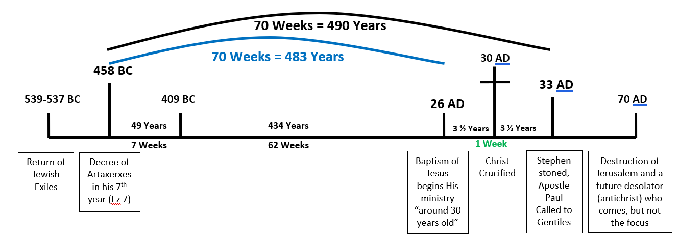

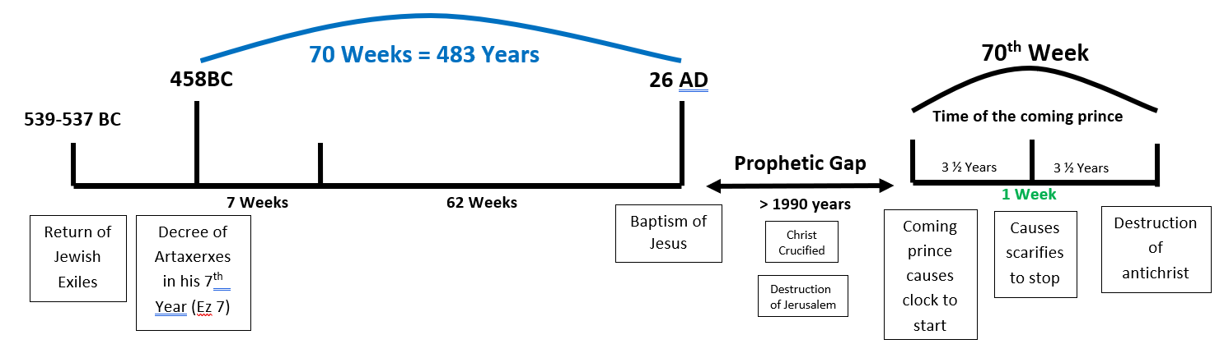

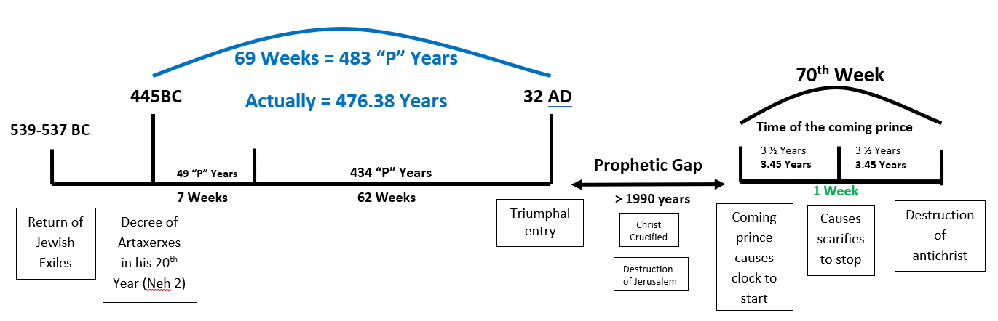

**Vs 26b** – (in context): **25 Know therefore and understand that from the going out of the word to restore**

**and build Jerusalem to the coming of an anointed one משׁיח *(maw-shee’-akh), a prince* נגיד *(naw-gheed’), there shall be seven weeks. Then for sixty-two weeks it shall be built again with squares and moat, but in a troubled time. 26 And after the sixty-two weeks, an anointed one* משׁיח *(maw-shee’-akh* *shall be cut off and shall have nothing. And the people of the prince* נגיד *(naw-gheed’)*****who is to come shall destroy the city and the sanctuary. Its end shall come with a flood, and to the end there shall be war. Desolations are decreed.**

Some people believe:

1. Jesus is described as the coming Messiah and King in Vs 25
2. Jesus is described as the coming Messiah in Vs 26a
3. Jesus is described as the coming King in Vs 26b

If that is correct, the logical question. The city and the sanctuary were destroyed in 70AD, how can we say that it was the Messiah’s people that did it? **Their rejection of the Messiah guaranteed it!**

*“****41*** *¶ And when he drew near and saw the city, he wept over it,* ***42*** *saying, "Would that you, even you, had known on this day the things that make for peace! But now they are hidden from your eyes.* ***43*** *For the days will come upon you, when your enemies will set up a barricade around you and surround you and hem you in on every side* ***44*** *and tear you down to the ground, you and your children within you. And they will not leave one stone upon another in you, because you did not know the time of your visitation."” (Lu 19:41-44 ESV)*

They failed to recognize their KING! Let me show you in context:

*“****12*** *¶ The next day the large crowd that had come to the feast heard that Jesus was coming to Jerusalem.* ***13*** *So they took branches of palm trees and went out to meet him, crying out, "Hosanna! Blessed is he who comes in the name of the Lord, even the King of Israel!"* ***14*** *And Jesus found a young donkey and sat on it, just as it is written,* ***15*** *"Fear not, daughter of Zion; behold, your king is coming, sitting on a donkey’s colt!"” (Joh 12:12-15 ESV)*

This was happening in fulfillment of Zech 9:9:

*“Rejoice greatly, O daughter of Zion! Shout aloud, O daughter of Jerusalem! Behold, your king is coming to you; righteous and having salvation is he, humble and mounted on a donkey, on a colt, the foal of a donkey.” (Zec 9:9 ESV)*

The people are crying blessed is the one who comes in the name of the Lord, **“even the king of Israel.”**

**In spite of all the evidence the religious community rejected their Messiah and moved the people to call for his execution! Now insert Luke 19:41-44**

**Vs 27a** - ***And he shall make a strong covenant with many for one week, and for half of the week he shall put an end to sacrifice and offering.***

Notice, in the middle or half of the week, he shall cause sacrifices and offerings to cease. At that point, once Jesus offered himself animal sacrifices were no longer acceptable, for the lamb of God had offered Himself!

If the “he” is the Messiah, the fits the timeline of Jesus’s life. We recognize that when the “lamb of God” died for the sins of the world, the blood of bulls and goats were no longer necessary, for their purpose of pointing forward to the death of the Messiah was no longer necessary.

*“****15*** *And the Holy Spirit also bears witness to us; for after saying,* ***16*** *"This is the covenant that I will make with them after those days, declares the Lord: I will put my laws on their hearts, and write them on their minds,"* ***17*** *then he adds, "I will remember their sins and their lawless deeds no more."* ***18*** *Where there is forgiveness of these, there is no longer any offering for sin.* ***19*** *¶ Therefore, brothers, since we have confidence to enter the holy places by the blood of Jesus,” (Heb 10:15-19 ESV)*

The use of many is very interesting here. This is new covenant language. The many is a word used for those who will be saved.

*“****10*** *¶ Yet it was the will of the LORD to crush him; he has put him to grief; when his soul makes an offering for guilt, he shall see his offspring; he shall prolong his days; the will of the LORD shall prosper in his hand.* ***11*** *Out of the anguish of his soul he shall see and be satisfied; by his knowledge shall the righteous one, my servant, make many to be accounted righteous, and he shall bear their iniquities.” (Isa 53:10-11 ESV)*

*“****13*** *But the angel said to him, "Do not be afraid, Zechariah, for your prayer has been heard, and your wife Elizabeth will bear you a son, and you shall call his name John.* ***14*** *And you will have joy and gladness, and many will rejoice at his birth,* ***15*** *for he will be great before the Lord. And he must not drink wine or strong drink, and he will be filled with the Holy Spirit, even from his mother’s womb.* ***16*** *And he will turn many of the children of Israel to the Lord their God,” (Lu 1:13-16 ESV)*

See also: Luk 2:34 and Mat 20:28

Some people believe:

1. Jesus is described as the coming Messiah and King in Vs 25
2. Jesus is described as the coming Messiah in Vs 26a
3. Titus is described as the coming King in Vs 26b

If you hold this view, you likely believe that Titus is serving as a type or there is a second fulfillment that involves the antichrist, otherwise the antecedent pronoun “he” in verse 27 would refer to Titus. We know that Titus did not enter into a covenant for 3 ½ years.

Some people believe:

1. Jesus is described as the coming Messiah and King in Vs 25
2. Jesus is described as the coming Messiah in Vs 26a
3. The antichrist is described as the coming King in Vs 26b

If you hold this position, you will likely still believe that vs 26 starts out about Titus and then changes to the antichrist, otherwise you have the antichrist destroying the city and sanctuary in verse 26 and then making a covenant that stops sacrifices in verse 27. Those sacrifices would have already been stopped.

**These are difficult verses and that explains why there are so many interpretations!**

**Vs 27b** - Here, is the likely reference to the antichrist. The language is archaic, but there is one coming, who makes desolate, and will do so until the decreed end is pour out upon that desolator. **Is there a coming antichrist? YES! But the focus of this prophecy is on the coming Messiah and King.**

_____________________________________________________________________________________________________________________________________________________________________________________________