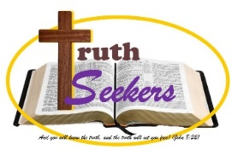
The Revealed Mysteries
In the New Testament the Greek word: μυστήριον (musterion), is used to describe something that was previously unknown or at a minimum not clearly revealed to something this is now revealed and can and should be known and understood. It was a mystery, it is now revealed.
The Greek word is used μυστήριον is used 27 times and in all cases for the ESV it is translated as either secret or mystery.
It seems to me that the total different mysteries that the scriptures mentions are 13 (outlined below), but you could come to another count depending on what you combine or separate. Equally, this is not to say these are the only mysteries, but they are the one men (as moved by the Holy Spirit) Record.
Mysteries
1) Mystery of the Kingdom (Mar 4:11)
2) Mystery of Israel’s partial blindness (Ro 11:25)
3) Mystery of the Gospel (salvation by faith) (Rom 16:25, Eph 6:19)
4) Mystery of the rapture (ICor 15:51)
5) Mystery of Jews and Gentiles in one body (Eph 3:3-9)
6) Mystery of the Bride of Christ (Eph 5:28-33)
7) Mystery of God living in You (Col 1:26-27)
8) Mystery of Christ Himself (Col 2:1-2, ITim 3:16)
9) Mystery of Lawlessness (II Thes 2:7)
10) Mystery of Faith (I Tim 3:9)
11) Mystery of the Seven Stars (Rev 1:20)
12) Mystery of the Consummation (Rev 10:7)
13) Mystery Babylon Rev 17:5-7)

