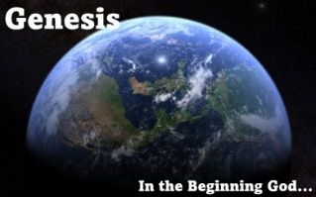**Generations of Esau (Gen 36)**

**(Esau’s Descendants Born in the Promised Land)**

**Generations of Esau (Gen 36)**

**(Esau’s Descendants Including Those Born in Mt Seir)**

**Descendants of Seir the Horite (Gen 36)**

**Kings of Edom (Gen 36)**

|  |  |  |
| --- | --- | --- |
| **Kings Name** | **Son of** | **Capital City** |
| **Bela** | **Beor** | **Dinhabah** |
| **Jobab** | **Zerah** | **Bozrah** |
| **Husham** | **Not listed** | **Temanites** |
| **Hadad** | **Bedad** | **Avith** |
| **Samlah** | **Not listed** | **Masrekah** |
| **Shaul** | **Not listed** | **Rehoboth on the Euphrates** |
| **Baal-hanan** | **Achbor** | **Not listed** |
|  |  |  |