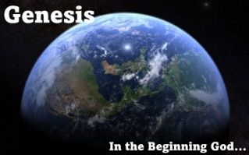

**Ten Anticipations of Eternity in Genesis**

Genesis is not only history of the origin of the universe, but it is also a prophecy of man’s final future. Paradise is lost in genesis and the entire cosmos is plunged into sin. Paradise is regained in the Revelation and we see the amazing contrast to the world after the Fall (in Genesis) to the world after our Lord’s final redemption (in the Revelation).

In Genesis we have the probationary world, a world created for man, but a world that was innocent and untested, a world that was probationary. It was in this probationary world where man sinned and plunged the entire cosmos into sin and ruin. It was in this world, that the God-man Jesus Christ, the promised Messiah stepped into, to pay the debt that was demanded because of man’s sin, to offer forgiveness to those who would receive it by faith, to atone for their sins, and to accomplish redemption. In the final world, as presented in the Revelation we see some amazing contrasts:

**Cursed World** **Eternal World**

Death becomes a reality (3:19) Death is eliminated (21:4)

Ground is cursed (3:17) No more curse (22:3)

Presence of sorrow (3:16) No more sorrow (21:4)

Thorns and thistles (3:18) No more pain (21:4)

Sweat on the face (3:18) Tears wiped away (21:4)

Evil continually (6:5) Nothing that defiles (21:27)

Satan is opposing (3:15) Satan is banished (20:10)

Kept from the tree of life (3:24) Access to the tree of life (22:14)

Banished from the Garden (3:23) Free entry to the city (22:14)

Redeemer promised (3:15) Redemption accomplished (5:9, 10)

There are of course many more, but again, my goal is to get us thinking and considering as we launch off on this amazing study in Genesis.